Day in the Life of the Hudson River 10/13/22
Bush Terminal Park, Brooklyn
RIVER MILE: -3.7
Salt Front: ~ 76
Sunset Park High School– Katie McCarthy
Billion Oyster Program - Shinara Sunderail, Briana Leddy, Emily Liang
51 students & 15 adults
Latitude 40.654525 N & Longitude – 74.018978 W
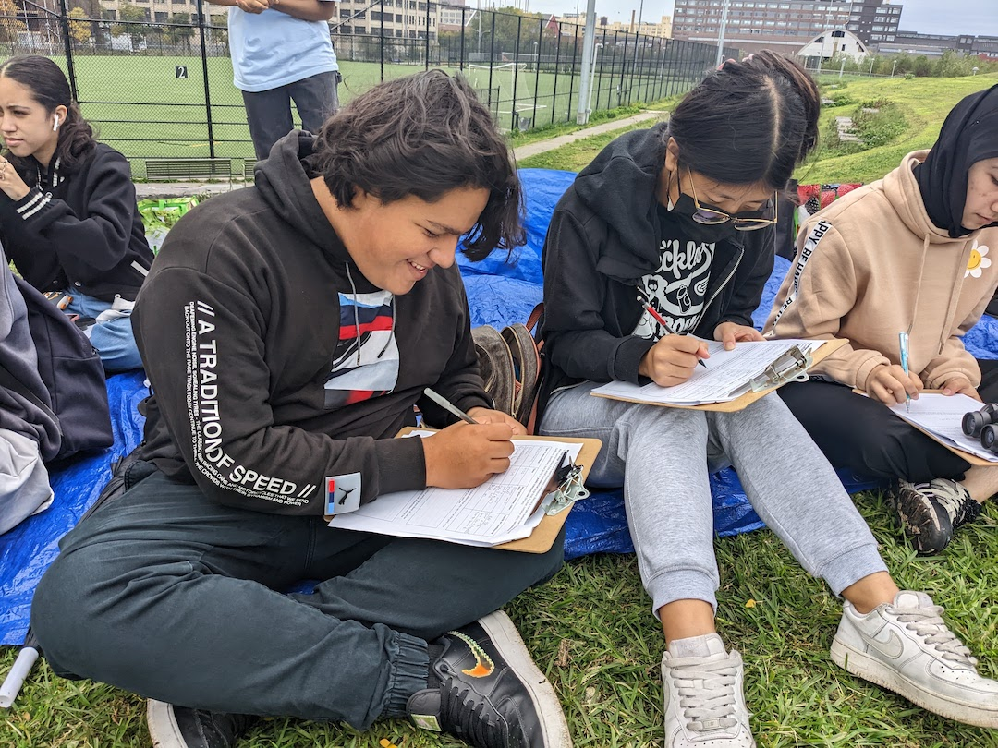 | 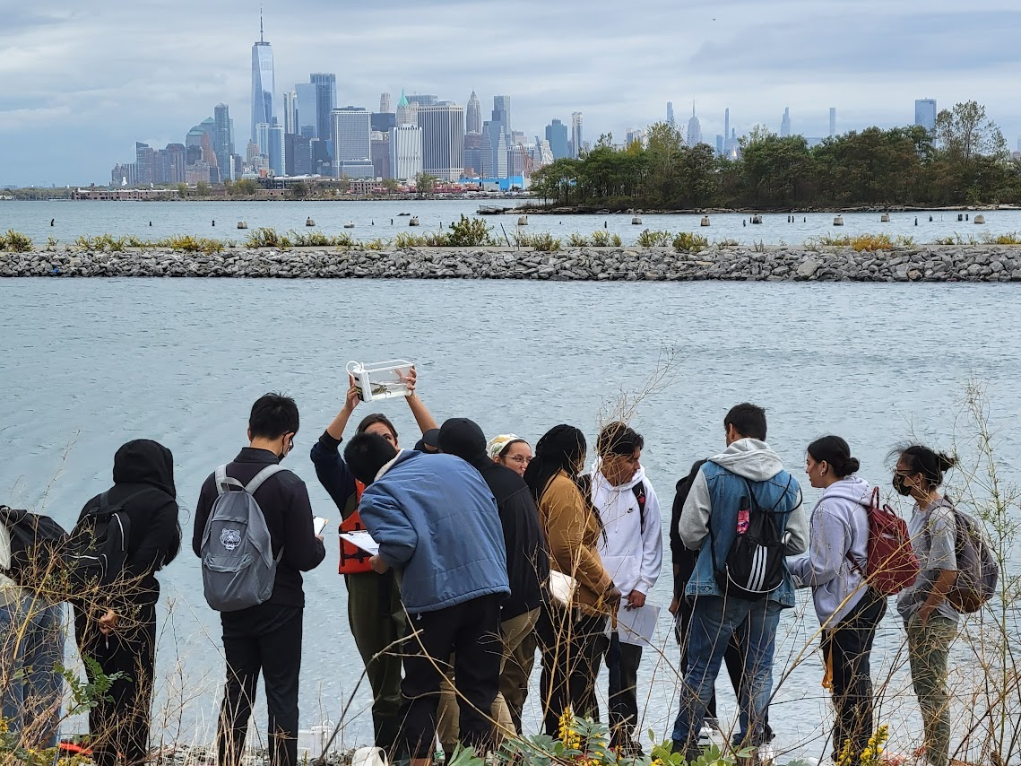 | 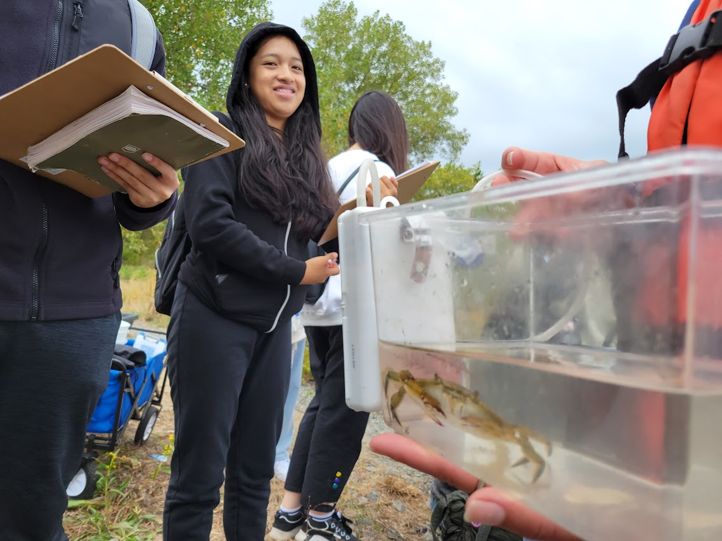

Location: Bush Terminal Park, New York Harbor
Area: Old industrial waterfront area surrounding a small marshy bay with a rocky shoreline, by the water, with grassy hills in Bush Terminal Park.
Surrounding Land Use: 80% Abandoned Industrial, 20% reestablishing park use
Sampling Site: RipRap/rocky shoreline
Shoreline: 50% concrete/asphalt; 20% dirt/gravel; 30% grass/trees
*NR = Not read/recorded
ITEM |  | Time |  | Reading |  |  |  | Comments
Physical
Air Temperature- |  | 9:47 AM  11:50 AM |  | 23°C  20.2°C  19.9°C  19.4°C |  |  | 73.4°F  68.4°F  67.8°F  67°F
Wind Speed: |  | 11:00 AM |  | Anemometer  5.5 mph w/ 14 mph gusts |  |  | Beaufort  NR | Direction  SW
Weather today |  | 10:50 AM |  | >75% cloud cover |  |  | No Rain
Weather the past 3 days: |  | No Rain last 3 days, very windy
Tides- |  | Time |  | Rising, Falling, Unchanged |  |  | Water Height (cm)
 |  | NR |  | Rising |  |  | NR | HT: 11:17 AM  LT: 5:51 PM
Current- |  | Time |  | Cm/sec |  | Knots | North/South | Ebb/Flood/Still
 |  | 9:47 AM |  | NR |  | NR | NR | Still
Water Temperature- |  | 11:35 AM  12:37 PM |  | 15°C  15°C  18°C |  |  | 60°F  60°F  64.4°F
Turbidity- Long Sight Tube (120 cm) |  | 11:40 AM  11:50 AM |  | 100 cm  103 cm
Chemical
Salinity-Refractometer |  | 9:47 AM  11:00 AM |  | 23 ppt  23 ppt  20 ppt
Standardized Salinity – Refractometer |  | 11:15 AM |  | 26,000 ppm
DO – Chemets Kit |  | Time  11:28 AM  11:30 AM  12:40 PM |  | Temp  18°C  15°C  18°C |  |  | ppm DO  6 ppm  4 ppm  5.75 ppm | % saturation  NR
pH – Color Match Kit |  | 11:44 AM  11:45 AM  12:45 PM |  | 8  7  8  7  7.5  7.5  8
Nitrates- |  | 10:22 AM  11:56 AM |  | 1.0 ppm  1.0 ppm
Phosphates- NR
Alkalinity- NR
Biological
Fish – Seine |  | Number |  | Name |  |  | Length of longest | Length of smallest
10:00 AM-11:00 AM |  | 2  5 |  | Striped Bass  Atlantic Silverside |  |  | 8 cm  5 cm | 5 cm
Fish Totals |  | TOTAL: 7 |  | Diversity: 2
Macroinvertebrates |  | Number |  | Name |  |  | Length of longest | Length of smallest
 |  | 1  1  2 |  | Blue Crab (M)  Blue Mussel  Mud crab |  |  | 8 cm  1.1 cm  5 cm
Macroinvertebrate Totals |  | TOTAL: 4 |  | Diversity:3
Sediment Core - N/A
Length | H2S smell |  | Oxid Top |  | Oil |  | Grain Size | Other Features
NR
Boats
 | Time |  | Name |  | Color |  | North/Southbound | Light/Loaded
Commercial | 9:59 AM-2 boats  10:01 AM  10:02 AM  10:10 AM  10:37 AM  10:40 AM  10:42 AM |  | Public Transport  Public Transport  Ferry  Cargo Ship  NR  Cargo Ship  Sightseeing Boat |  | White and Blue  White and Blue  Blue and White  Black  Yellow  Red  White |  | Northbound & Southbound  Northbound  NR  NR  Northbound  Northbound  Southbound | NR  NR  NR  Loaded  NR  NR  NR
Recreational | 9:55 AM  10:03 AM  10:12 AM  10:15 AM  10:36 AM |  | NR  Fishing Boat  Yacht  Staten Island Yacht  Speedboat |  | Red  Red w/ pink M  White  Orange and Black  Yellow |  | Northbound  Northbound  NR  NR  Northbound | NR  NR  NR  NR  NR

